MSc Project Definition: Using NLP To Assign Political Compass Values

School of Electronic Engineering and Computer Science

Queen Mary University of London

2022-2023

# Details

**Project Title:** Using NLP to assign Political Compass values to public speech

**Supervisor:** Arkaitz Zubiaga

Student Name: Alexander Martin Hey

Student Email: [a.m.hey@se22.qmul.ac.uk](mailto:a.m.hey@se22.qmul.ac.uk) / [ec221139@qmul.ac.uk](mailto:ec221139@qmul.ac.uk)

# Project Aims

This aim of this project is to develop a NLP model that can correctly identify a person’s position on a political compass. This will be done through the use of public statements from prominent figures utilising multiple APIs. This will then be used to train up a NLP model to correctly identify their position on a political compass.

The Political Compass is a test that was created in 2001 and has been commonly used to give a graphical representation of where someone may align politically. While most people only recognise a single axis (left leaning or right leaning), the compass plots an additional axis; authoritarian or libertarian.

Figure 1 (Example of Political Compass Layout) (www.politicalcompass.org, n.d.)

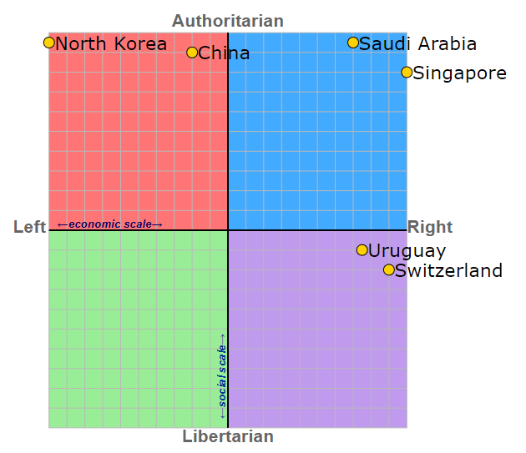

# Related Reading

Political compass: <https://www.politicalcompass.org/about>

Detecting Political Bias in News Articles Using Headline Attention: <https://aclanthology.org/W19-4809/>

Measuring Proximity Between Newspapers and Political Parties: The Sentiment Political Compass: <https://onlinelibrary.wiley.com/doi/abs/10.1002/poi3.222>

# Relation To Topic

While I am by no means an expert, politics has been a personal interest of mine for quite a long time. In this project, I will make every attempt to make the report as neutral as possible. If any assumptions need to be made around classifying a person or group, I will make sure to collate multiple sources and not base it on my own opinion.

Closely related to this, I also have a keen interest in NLP models. With the explosive growth of predictive models such as ChatGPT and NovelAI, this area has become an extremely complex and ever expanding area of interest. I would like to develop a tool that would both be interesting, as well as act as a foundation to my future career.

# Project Plan

## Initial Research

The first step in the process is to gather more information about how the political compass functions and where/who I will collect the data from. This will include getting set up with multiple APIs and performing research into specific policies.

## Gathering Data

After the research is complete, I will utilise a variety of APIs to correctly collect and categorise data into many different categories. This will be done using the following APIs:

* Reddit
* Twitter
* Instagram
* Multiple Opinion News Sights (Possible)
  + Vox
  + Huffington Post
  + Buzzfeed
  + The Daily Wire
  + The Daily Mail

## Building NLP Model

Using the data found above, I will process the data and create a NLP Model to classify positions on a political compass as correctly as possible.

## Testing NLP Model

Once the model has been created, I will use cross validation to make sure that the results are appropriate.

## Improving NLP Model

Once the initial model has been tested, I will use this information to attempt to improve the system and develop a better model.

## Building Extension (Tentative)

If the above steps are completed correctly, I will attempt to develop a chrome extension to utilise the NLP Model on any users tweets. This may not be feasible however is an additional avenue to proceed down if required.

# Required Knowledge/Tools:

This project will require a significant amount of research into NLP techniques. This will be done to make sure that the model that will be created functions as well as possible. In addition to this, I will also conduct research into how each of the questions affect the results of the political compass.

The majority of this project will be programmed in Python 3 using a variety of Libraries. This will include connection libraries so that Python can integrate directly with multiple API.

# References

www.politicalcompass.org. (n.d.). *Political Compass*. Retrieved from https://www.politicalcompass.org/analysis2?ec=0.0&soc=0.0